Whoopee Trousers: Young Men’s Style or Mere Catchphrase?
By Laurie Elliott, Santa Clara Valley Chapter

The ad in a M.W. Savage Co., Spring/Summer, 1931 catalog really caught my eye as both the header at the top of the page and the drawing of the center model who was wearing rather wild pants held a banner that used the word “Whoopee.” A song began playing inside my head:
“Another bride, Another groom, Another sunny honeymoon,
Another season, Another reason, For making whoopee.”

The song, usually referred to as “Makin’ Whoopee!” is a jazz/blues song popularized by Eddie Cantor, published and released in November 1928 and appeared in the musical play “Whoopee!” that same year. A movie version of the play was made in 1930. The song has been recorded by numerous artists from Rudy Vallee to Cyndi Lauper and appears in many movies and TV shows, including Sesame Street where Cookie Monster croons his version, “Eating Cookie.” Clearly this song was popular, but I doubt the suggestive “whoopee” in the song means the same thing as the “whoopee” in the ad, which is defined by Webster’s as a cry of joy or excitement. Perhaps the ambiguous meaning was part of the appeal by savvy copywriters.

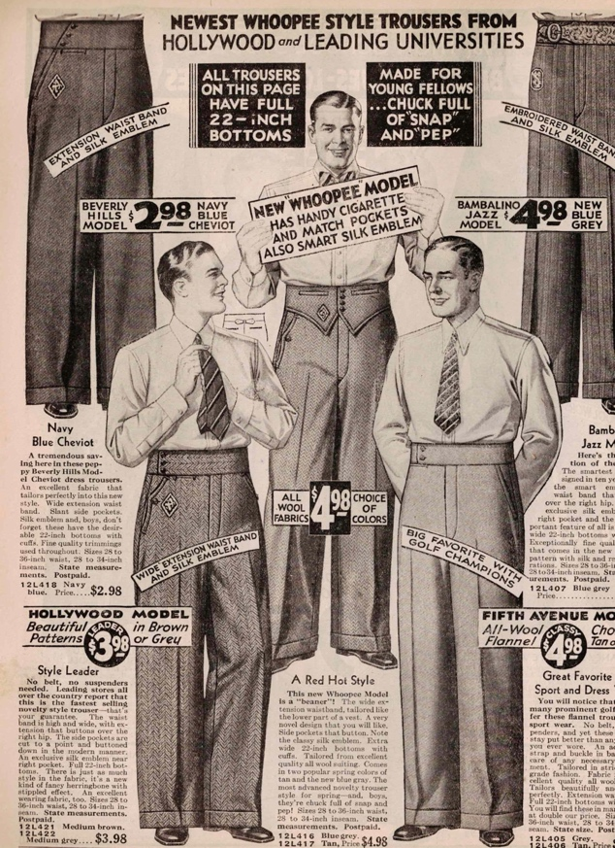
The “Whoopee Style” Ad

By today’s standards, these trousers look pretty tame, but in the Model A years of 1928-1931, they were downright imaginative. The ads were mostly aimed at young collegiate men or high schoolers with waist sizes 28” through 36”.

The variety of trouser features are shown in the page at left. Some slacks had extended waistbands which may or may not have been shaped, and many had the “new” taller waistbands of 2-3”. The text reads, “No belt, no suspenders needed.” An adjustable strap and buckle in the back allowed for easy fitting. The 22” wide pant legs were almost always cuffed. Exclusive silk embroidered emblems might be offered near the right pocket.

The pants were made of all wool, wool and cotton blends, or unspecified fabric content, in plain weaves, stripes, tweed or herringbone designs. Colors were grey, tan, medium brown, navy blue, and blue grey.
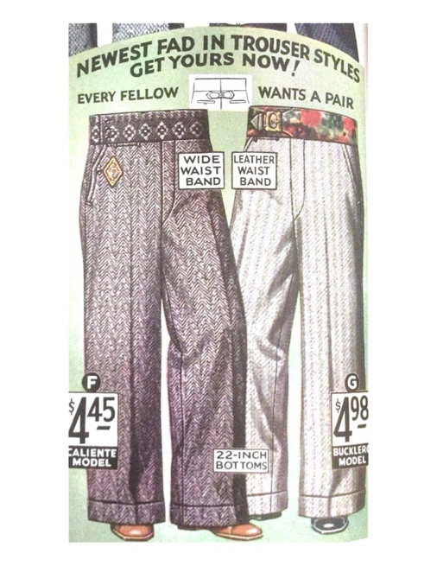
Sometimes, very unusual or colorful pants weren’t even identified with the words “Whoopee Style.” Take a look at the two pair in the ad pictured at right in M.W. Savage Co. Spring & Summer 1931. Very similar trousers (but with 19” wide cuffs) also appeared in 1928’s National Bella Hess Co.’s Summer Sale catalog. “Collegiate cut,” “Fancy,” “Snappy,” and “Swagger” are words used to enhance the product descriptions.

Similar pants offered in sizes 6-16 years, and 27”-32” waists, may have had full elastic waistbands or elastic waistbands in the back with a plain front. Many listings for young men’s or boy’s styles such as these models state, “Just like big brother’s!” but not, “Just like Dad’s!” Hmmm, I wonder why?
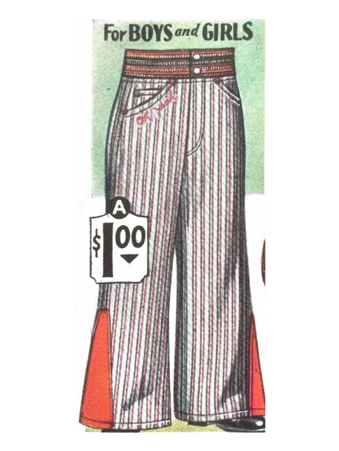
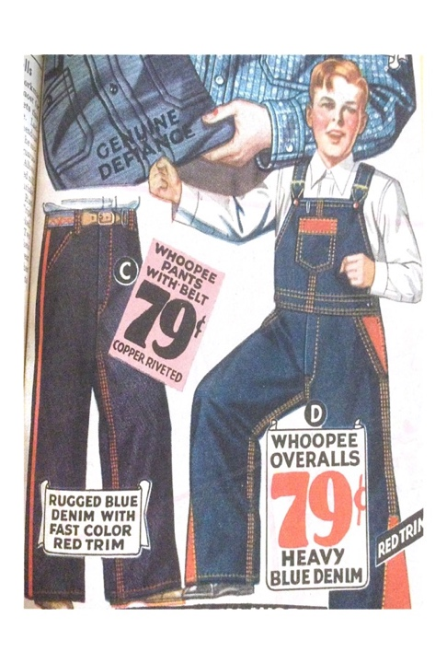

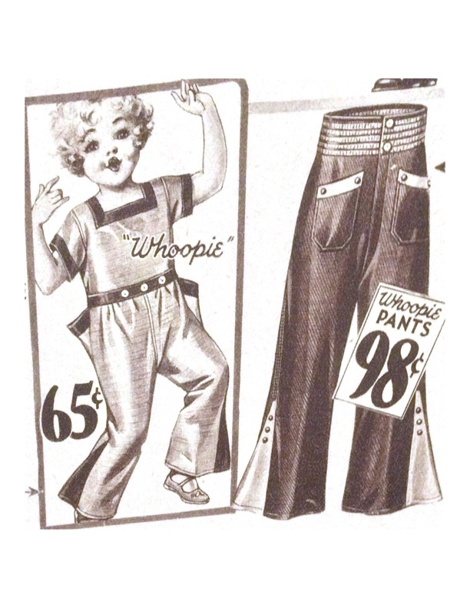“Whoopee” pants for boys or girls in blue denim with red stitching, or in combinations of red and blue fabric were numerous. There were also examples that were a bit more subdued, but colorful compared to solid fabric with matching color stitching. Overalls and playsuits, stressed durability and were offered in children’s sizes. The overalls and denim pants in the ad at far left, came in sizes for boys and girls up to age sixteen years.

All three of the examples above are from M.W. Savage Co. Spring & Summer 1931. Why are so many of my examples from this particular catalog? This catalog just happened to have illustrations in color or with arrangements that copied easily.

Other Whoopee Clothing

We’ve looked at “Whoopee” pants for young men and playsuits for children but were there any other types of clothing or age groups targeted for Whoopee advertising? Yes, actually, there are a couple more examples.

This unexpected listing from the Montgomery Ward & Co. Fall & Winter 1929-30 catalog reads, “First seen at the smart resorts – and now gaining popularity everywhere. Wear them over [emphasis mine] your regular stockings for an extra touch of smartness.” These colorful anklets are offered in women’s sizes 7 – 10, and are more colorful than the other women’s hose and socks in this catalog.
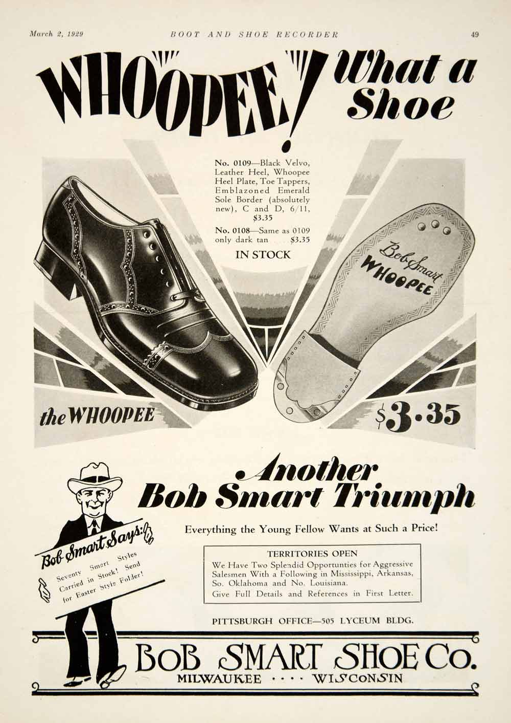
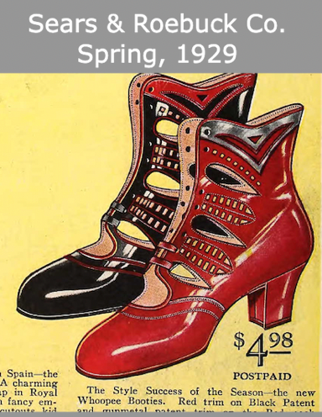
The shoes at left earned their moniker of Whoopee Booties. Offered in patent leather, in red with black trim or black with red trim, these would have been very colorful additions to a women’s outfit, and at $4.98 a pair, were priced $1 – $2 higher than most women’s leather shoes.

The men’s shoe ad to the right uses Whoopee! with great affect. From March, 1929, it describes the shoe as having a “Whoopee heel plate, toe tappers…” and appears to have the word Whoopee printed or etched into the sole, just in case anyone needed clarification. Special thanks to MAFCA Fashion Editor, Sherry Winkinhofer, for these two ads.

Winners and Duds

All of the examples seen above seem to have earned their descriptions as “Whoopee Style” to varying degrees. Below are a couple of duds in my opinion, where the word whoopee is clearly added to get the reader’s attention, but the products are plain and without any stylistic flair.

While this pair of men’s shoes is typical for the time period and seem nice enough, the only new aspect is that they are now offered in navy blue in addition to the usual black or brown. Is this flamboyant enough to earn a Whoopee appellation?

The men’s wool hat to the right first appears to be shapeless and without spark, but imagine it in Royal blue, light green, red or purple! Maybe it has earned its Whoopee title after all, but I wonder just how many were sold or worn in public. Both of these listings are from National Bella Hess Co. Spring & Summer 1930.

Conclusion

I hope you got a kick out of my casual sampling of Model A clothing ads. Interestingly, I didn’t find any ads for women’s dresses, pants or pajamas using the term Whoopee. And definitely not a single ad for any women’s step-ins, bloomers, or any kind of underwear or union suit for women or men. Was “Whoopee Style” a distinctive style in the Model A years? I highly doubt it, but the catch phrase absolutely got my attention!

Sources:
Montgomery Ward & Co. Chicago, Fall & Winter 1929-30.
M.W. Savage Co. Minneapolis, Spring & Summer 1931.
National Bella Hess Co. Inc. New York City, Annual Summer Sale Catalog, 1928.
National Bella Hess Co. Inc. New York City, Spring & Summer, 1930.

#######

