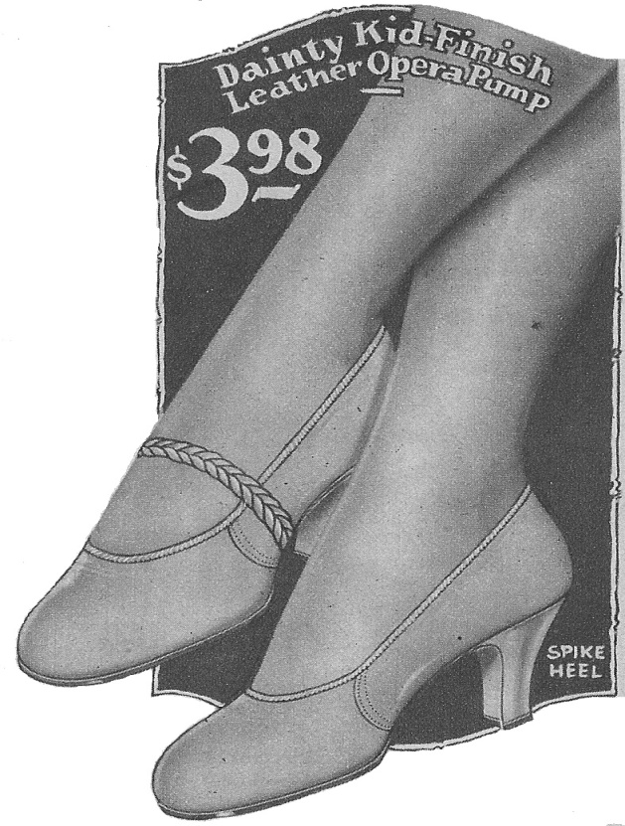
PUMP HOLDER

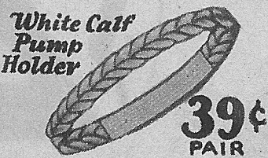

When looking through a newly acquired Model A era catalog I noticed something I thought was unusual. I have not see this item before, has anyone else ever seen these?
These braided leather pump holders have elastic under the instep. They are advertised to “hold pump firmly on foot and adds a dressy touch.” So to explain this item, it’s simply a braided section of leather with elastic sewn to it, to make a loop, that would slip over the toe of your pump. (Note the illustration on the upper shoe.)
These pump holders were advertised in the ladies and girls section, sold separately from the shoe. Illustrations are from a 1928 S/S National Bellas Hess catalog.

Submitted by Jeanie Adair, Era Fashions Committee, April 2011

